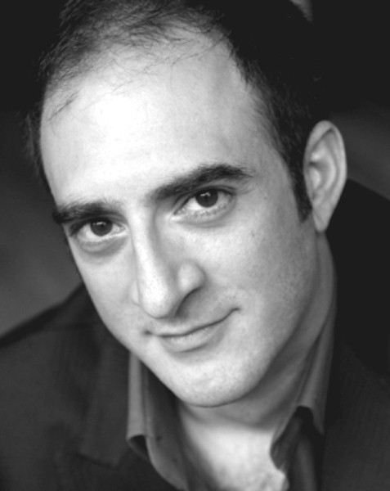

James Zannelli

AEA/AGMA

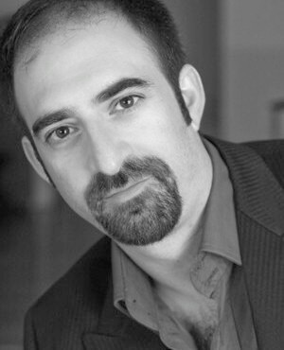

Prestige Talent Management – 212-239-6785

NEW YORK
Simon Stride Jekyll and Hyde (directed by Steve McCoy and Donny Jones) John W. Engeman Theater
Mr. Peters/Reporter Ripper (by Duane Nelsen, directed by Stephen Amato and Mike Morris) New World Stages

Broadway Chorus Children and Art: A 75th Birthday Gala Celebration for Stephen Sondheim New Amsterdam Theatre
(directed by Richard Maltby Jr. with musical direction by Kevin Stites)
Man The Rubberers (presented by Musicals Tonight, directed by Thomas Caruso and Linda Dowdell) McGinn Cazale Theatre
Otto The Legend of Sleepy Hollow (musical direction by Rachel Kaufman) York Theatre

Brom Van Brunt The Legend of Sleepy Hollow (musical direction by Seth Bisen-Hersh) Dramatist’s Guild
NYCGMC You Oughta Be in Pictures: New York and the Movies (directed by Casey J. Hughes) Avery Fisher Hall

Regional Theater

Molokov Chess (directed by Casey Hushion, Josh Rhodes and Eddy Robinson) North Carolina Theatre

Sir Dinadan Camelot (starring Debby Boone, directed by Stephen Terrel and McCrae Hardy) North Carolina Theatre

Simon Stride Jekyll and Hyde (starring Sebastian Bach, directed by Casey Hushion and Michele Lynch) North Carolina Theatre

Caiaphas Jesus Christ Superstar (directed by Jack Allison, Keisha LaLama-White and Dale Rieling) KS City Starlight Theatre

Monsieur D’Arque Beauty and the Beast (starring Lauren Kennedy, directed by Matt Lenz and Michele Lynch) Fox Theatre, Detroit

Steward Into the Woods (directed by Glenn Casale) Sacramento Music Circus
Zoltan Karpathy My Fair Lady (starring Paul Schoeffler, directed by Glenn Casale) Sacramento Music Circus
Pete Gavin Show Boat (starring Richard White, directed by Leland Ball) Sacramento Music Circus

Thomas Andrews Titanic (directed by Jesse Cline) Media Theatre

Captain Hook Peter Pan (directed by Jesse Cline) Media Theatre

Major Holmes The Secret Garden (directed by Michael Mitchell and Marc Robin) Fulton Opera House

Aristocrat Evita (directed by David Grapes and Lynne Kurdziel-Formato) Tennessee Rep. Theatre

Prince/Wolf Into the Woods (directed by Michael Barnard and Ron Colvard) Phoenix Theatre
Noah Children of Eden (directed by Michael Barnard and Jerry Wayne Harkey) Phoenix Theatre
Dr. Carrasco Man of La Mancha (directed by Michael Barnard and Ron Colvard) Phoenix Theatre
Miles Gloriosus A Funny Thing Happened on the Way to the Forum (directed by Jared Sakren) Shakespeare Sedona

Miner (originated role) A Christmas Carol (directed by Matthew Wiener and Craig Bohmler) Actors Theatre Of Phoenix

Sergeant (cover) Pirates Of Penzance (directed by Bill Theisen and Bob Tweten) Santa Fe Opera

Second Soldier Salome (directed by Sonja Frisell and Stephen Lord) Arizona Opera

Commissioner Madama Butterfly (directed by Rosalind Elias and Cal Kellogg) Arizona Opera

Jose Castro La Fanciulla Del West (directed by Joe McClain and Willie Anthony Waters) Arizona Opera

Morales Carmen (directed by James McNamara and Cal Kellogg) Arizona Opera

Zaretsky Eugene Onegin (directed by Sonja Frisell and Stephen Lord) Arizona Opera

Recordings

Rock Chorus Metal Messiah (music and lyrics arranged by Jason Howland and Dani Davis)

Training

Voice: Aaron Hagan, George Gibson, Gail Dubinbaum

Acting: David Barker, Danny Irvine, Claude Pensis
Dance: Moves well and willing to work hard
Coaches: Tina Marie Casamento, Brad Ross, Richard Sabellico, Craig Bohmler, Tregoney Shepherd

Education: Master of Music from Arizona State University, Bachelor of Music from Grand Canyon University

Skills

Sword Fighting ; Basic Tumbling/Gymnastics; Excellent Sight Singer; Strong Falsetto; Working with Children; Various Dialects;

Piano Proficient ; Proficient in German, French, Italian & Latin Diction, Driving a car (standard or automatic)

